Interim Report

**Multiuser Poker Game for Mobile Devices**

December 6, 2018

**Matthew Winterbourn**

School of Computer Science

psymw6@nottingham.ac.uk

4276228

Supervisor:

**Milena Radenkovic**

School of Computer Science

pszmvr@nottingham.ac.uk

*Abstract*

Table of Contents

**1 Introduction** 4

1.1 History of Poker 4

1.2 Project Introduction 4

**2** **Motivation and Related Work** 6

2.1 Motivation 6

2.2 Related Work 6

**3** **Methodology** 9

3.1 Key Features 9

3.2 Development Process 9

**4** **Project Specification** 11

4.1 Functional Requirements 11

4.2 Non-Functional Requirements 12

**5** **Design** 14

5.1 Design Overview 14

5.2 Prototypes 14

5.3 User Testing 17

**6** **Progress** 18

6.1 Project Management 18

6.2 Contributions and Reflections 19

References 21

# **1 Introduction**

* 1. History of Poker

The origins of Poker have been debated at length by the historical community. It is reported that “In the year 969, the Chinese Emperor Mu-tsung played a game of “domino cards” with his wife” (Neal, 2011), which many historians have believed was the first ever game of the card game now known as poker. However, in the 1937 edition of Foster’s complete, R.F. Foster wrote “the game of poker […] is undoubtedly the Persian game of As-Nas” (Foster, 1937). Although the exact origin of Poker is disputed, the modern game of Texas Hold’em we know came to prominence in the 1970s with the World Series of Poker popularising it in a tournament setting (Anon., 2007) and it is this method of play that has become wildly popular in the 21st Century, both in-person and online formats being played and enjoyed globally.

* 1. Project Introduction

From the desktop computer to the mobile phone, the world today is becoming increasingly connected, with over “77% of Adults in the US owning a smartphone in 2018” (Pew Research Center, 2018) and studies showing that “91% of people with disabilities in the US own or use at least one of a cell phone, smartphone or tablet” (Morris, et al., 2016).

Despite this, the Play store presents a relatively sparse offering of mobile games with features designed to make them more accessible to users with issues such as sight or hearing impairment, such as TapBeats which was specifically created with the intention of “being accessible for users who are blind or have low-vision” (Joy & Ricaurte, 2011). This limited offering can be seen on this forum thread (Anon., 2015) which has a short list of aggregated games that support accessibility features on Android, mostly focusing on those that support the Android TalkBack feature for screen reading and does not appear to feature any variation of a Poker game at all.

This project aims to build a multiplayer poker application to be deployed on Android devices. It will be capable of connecting the application client to a host server that will allow multiple users to play against each other and include features to improve the game’s accessibility for new and less able users.

In order to provide this we will build a robust and secure server to handle the connections between users and process as well as another unit to process the core game logic and update the user’s client appropriately. This should be handled in real time and provide handling for instances in which clients abruptly or unexpectedly lose connection to the server so as to provide a smooth flow of gameplay for all users. Furthermore the server will implement select algorithms to ensure the fair and random shuffling of cards between hands as well as to efficiently calculate the outcome of each hand.

On the client side of this application we will face several Human Computer Interaction challenges involving creating a suitable interface for the user to interact with that will be clear and understandable for users of all ability, by implementing optional features that will, for example, providing support for the Android TalkBack feature to navigate the application or an alternative UI layout that emphasises the functional components of the app over a more aesthetically focused layout.

1. **Motivation and Related Work**
   1. Motivation

Mobile gaming has fast become one of the most profitable markets for gaming in the world, with projected revenue for 2018 marking the first time that more than half of all game revenues will come from the mobile segment and with revenue from mobile games alone projected to become a “100 billion dollar market by 2021” (Newzoo, 2018), from this we can see the stunning growth in popularity of mobile games and especially “the rise of multiplayer games which accompanied the advent of third generation network (3G) technologies” (Liu & Li, 2011).

It seems essential that in this new age where anyone can open their phone and expect to load up a multiplayer game and have it work almost anywhere that the game servers supporting this should be able to provide a robust and stable experience in order to retain a player base in today's competitive market. Sensor Tower even projects the Apple app store alone to “reach 5 million apps by 2020” (Sensor Tower, 2016).

As highlighted in the introduction, a large majority of people with disabilities use cellular devices (Morris, et al., 2016), however there is a significant disparity in apps designed to cater this audience.

These key points have convinced me of the need to develop more accessible games for Android and will be a key aspect alongside the creation of a robust and enjoyable multiplayer game of Poker capable of handling multiple game sessions connected together to provide an inclusive experience for all users.

* 1. Related Work

1. Zynga Poker

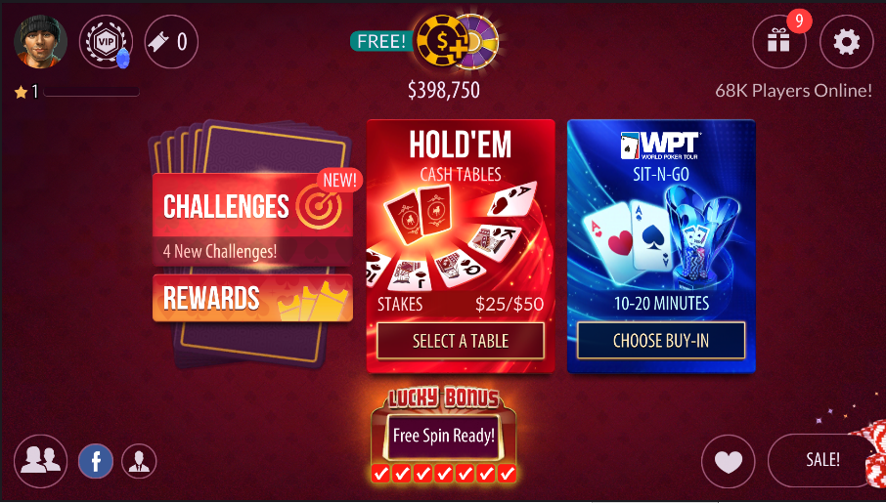

Fig. 1 Main Menu screen of Zynga Poker App

One of the most popular poker apps available on Android, with over 50 million downloads.

Key Features:

* Brief tutorial to introduce the interface
* Friends system which allows importing of friends from Facebook
* Ability to adjust the game speed and table size you would like to play at
* Has a tournament game mode for users to compete in
* Slot machine for earning currency – linked to real money currency purchases

1. World Series of Poker

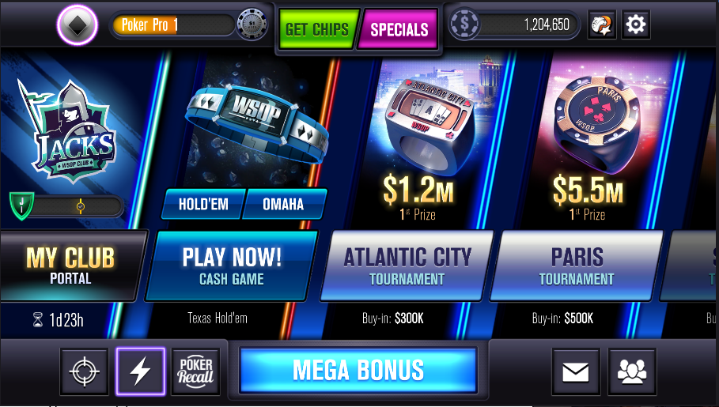

Fig. 2 Main Menu screen of World Series of Poker App

Named after the annual Las Vegas tournament, this app has over 10 million downloads on the Play Store and offers a robust gameplay experience with an overall clear layout.

Key Features:

* An extensive, narrated tutorial
* A chat system when playing at a Poker table
* Options menu has the option to show current hand strength, as well as disable extra features like the chat
* Friends system with Facebook integration
* A levelling system and VIP system tied to the user’s profile and playtime
* Displays game stats on the user’s profile
* Different levels of tournaments, with increasingly high buy-ins unlocked as the user ‘levels up’
* Can invite friends to join your current table
* Slot machine for earning currency – linked to real money currency purchases

1. World Poker Club

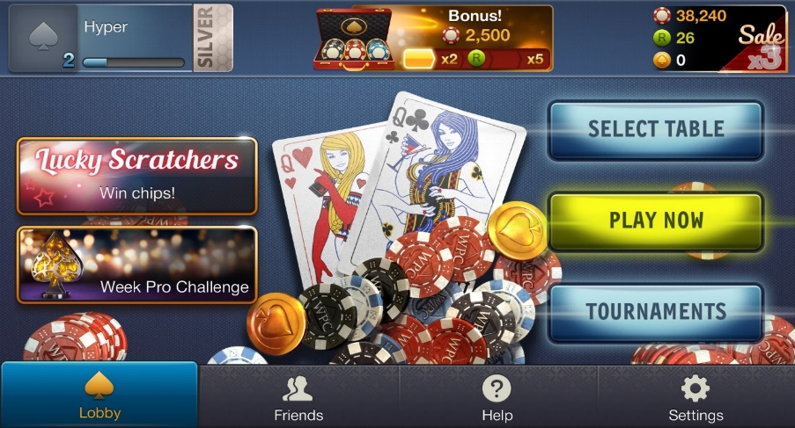

Fig 3. Main Menu Screen of World Poker Club App

Created by CrazyPanda, World Poker Club has a slick layout with labelled buttons for clarity, creating a satisfying and easy to navigate user experience.

Key Features:

* After missing a certain number of turns the user is marked as ‘AFK’ (away from keyboard), and their turn will be automatically skipped, but not removed from the table, until they come back
* Basic gesture controls for gameplay (bet, check, raise, fold etc)
* Scratch card minigame – linked to real money currency purchases
* Customisation of table settings, i.e the number of seats and blind amount
* Manual browsing through a list of tables
* Chat system with prearranged messages

Overall Poker apps tend to share a lot of functionality such as a friends system, user profiles and levelling, and the ability to buy currency to keep playing. With this being the case this project will attempt to build a similarly structured app, but with a focus on the core gameplay – Poker, over pointless minigames and systems designed to entice you into spending money. Furthermore, we will attempt to build a functional interface with a simple and clear layout that is highly learnable for all types of users in order to distinguish from other apps which appear to focus more on aesthetics over a user-friendly interface.

1. **Methodology**
   1. Key Features
2. **Facebook / Google account** **integration:** A staple of modern mobile gaming, account integration allows a smoother user experience, without the hassle of creating any new accounts and the convenience of being able to import their friends as well
3. **Accessibility**
   1. **Change layout mode:** An optional layout mode that focuses on delivering the main functions of the app, i.e. the buttons and removing the unnecessary menu and game graphics
   2. **Gesture control scheme:** The option to navigate between Activities using gestures and control the game with gestures which will aim to be highly learnable and an effective alternative control scheme for the game
   3. **Android TalkBack support:** A function designed to improve the user experience for users who have low-vision or are blind, TalkBack will be supported as fully as possible to be able to navigate and use the app
   4. **Voice command support:** Another form of control for the app, allowing users to interact with the app utilising voice commands, however is held at a lower priority due to the relative complexity of implementation
4. **Chat**
   1. **Main Menu chat:** A chat system for all users currently connected to the game to talk to each other and promote a more social friendly atmosphere, hopefully helped by the lack of real money investment in the game’s currency system
   2. **Table** **chat:** A chat system dedicated to users at a specific table, for more focussed discussion of the game at hand
5. **Virtual-only currency:** The currency to be used in the game, which will have no real monetary value, and will only be possible to earn by playing the game, without the addition of any ‘micro-transactions’ in order to create a ‘pure’ poker game, without the extra clutter of so called ‘mini-games’ that seem to be prominent in the most popular of games and the enticement to spend real money
   1. Development Process

This project will use an adapted form of Agile methodology, with a focus on implementing Test Driven Development for both the client and the server, in an effort to reduce defect rates and bugs in the system. This methodology was chosen in order to be more flexible with regards to changing requirements due to feedback from potential users that will be gathered throughout the development stages, so as to achieve the aim of providing a more accessible app.

1. **Project Specification**
   1. Functional Requirements
2. **Platform:** The application will run on all Android devices supporting the minimum API level specified in its creation.
3. **Login:** Users will be presented with a choice of methods to login to the app.
   1. Users will be able to login with a Facebook account
   2. Users will be able to login with a Google account

Users will be able to login with a guest account

* + 1. Users will be able to link their Facebook or Google account to the guest account

1. **Accessibility:** Users will have the option to enable features to increase the accessibility of the app.

The app will support the Android TalkBack feature to the best of its ability

The app will support an alternative layout mode which focuses on making the key gameplay elements as visible as possible (henceforth referred to as the ‘functional layout’)

The app will support gesture based controls

The app will support voice command controls

1. **Connections:** The app will handle connections from multiple clients in order to facilitate a Poker game between users
   1. The server will match users together from a queue to create virtual “Tables” where the game will be played and removing them from the queue
   2. The app will allow users to leave a table at any time, forfeiting any bet chips and returning to the main menu and disconnecting from the server Table
   3. The server will check users current connection status and:
      1. Remove users who have lost connection to the server from the current match
      2. Update connected users with information on the current game state
2. **Algorithms:** The app will implement algorithms in order to calculate the winner of each hand and to shuffle the cards between hands
   1. Durstenfeld’s improved Fisher-Yates shuffle algorithm will be used in order to shuffle the deck of cards
3. **Friends:** Users will be able to add other users as friends
   1. Users will be able to invite friends to their Table if it isn’t full
   2. Users will be able to import their Facebook/Google friends
4. **Chat:** The app will have a chat system for users to talk in
   1. The app will provide a separate chat for users at a Table to communicate in
5. **Data storage:** User data will be stored appropriately by the server
   1. User login data will be stored in a database server side to validate login requests
   2. User game data will also be stored server side for security and stability
6. **Game functions:** The app will provide an interface for the user to make game decisions with that will trigger the relevant actions by the server
   1. Users will be able to take the standard actions permitted within a game of Texas Holdem like Check, Bet, Fold etc with only relevant actions being shown in the screen
   2. The server will receive each user’s actions and apply them to the current game state and update accordingly
   3. User’s will have a common virtual currency, which will be used to bet with in game and will be carried between game sessions
      1. Users will be granted an amount of currency at account creation
      2. Users will be able to win and lose this currency in hands
      3. Users will be provided with currency on a daily based, scaled with login activity
7. **Interface:** The app will provide different menus, implemented as “Activities” in Android that can be navigated between to perform certain actions.
   1. The app will provide a login screen for users when the app launches until they choose a method of login
   2. The app will provide a main menu as a hub to provide access to the options, friend, chat, and game help menus.
   3. The app will provide an options menu to adjust options pertaining to accessibility features, general game features, and connected accounts
   4. The app will provide a friend menu for viewing friend’s profiles and adding friends
   5. The app will provide a chat screen for users to talk in from the main menu and the in game Poker Table screen
   6. The app will provide a game help screen to display the rules of poker for beginners, as well as a reminder of hand values
   7. The app will provide a Poker Table screen where the actual game will take place between users
   8. The app will provide a user stats screen displaying statistics saved in the user’s profile data on the server
   9. Non-Functional Requirements
8. **Usability:** The app should feature introductory tutorials designed to introduce key features of the User Interface, as well as how to use the main accessibility options. Otherwise use should be straightforward even for users with low experience with similar apps using highly learnable buttons that are easily recognisable, and minimising the number of activities displayed to the user
9. **Reliability:** The server side implementation will secure the stored data to prevent unauthorised users accessing it, and will be built to be robust and handle numerous connections at once without failure
10. **Performance:** Communication between the client and server should be completed with minimal delay, and the algorithms implemented in the server for calculating hand value and shuffling cards should not cause any noticeable slowdown when handling requests or sending game data. Additionally the app itself should not present any noticeable lag to the user when performing actions such as switching activities in order to maintain a smooth and enjoyable user experience
11. **Implementation:** The app will be created primarily in Java in order to be deployed on the Android Operating System with a corresponding server built in Java to communicate with
12. **Design**
    1. Design Overview

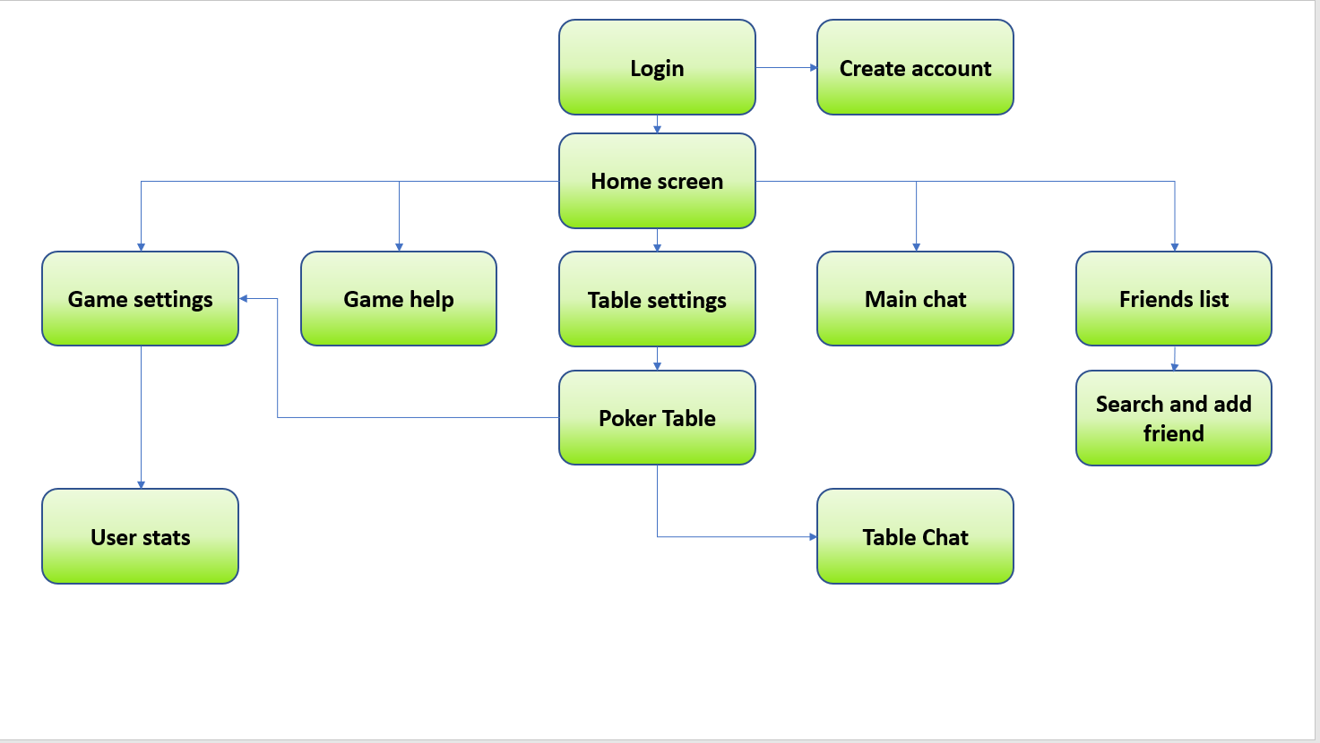

Fig. 4 App screen-relationship diagram

The core design of the project will be in two parts, following a client-server model. The application which will be released on Android devices will act as the client, and interface with the server, which will be developed separately.

The server will be created from scratch in order to have full control over the desired functionality of the system. The server will also have an attached mySQL database to handle user authentication for guest accounts and linked Facebook and Google accounts. This data will be stored online as if it is stored in the Android internal storage database provided it will have to be encrypted and could still potentially be tampered with if the encryption is not strong enough.

The client consists of multiple Activities presenting information to the user and communicating with the server when necessary. These Activities are presented as screens to the user and will provide links to navigate between them (Fig. 4).

* 1. Prototypes

Prototyping the User Interface commenced early in the project, in order to promote an iterative, user focussed design methodology. Low Fidelity prototypes were developed to this end and testing was used to gauge the potential learnability and usability of the prototype. The prototyping was software aided in order to add interaction so that users could get a feel for how the app would run and provide more relevant feedback.

The initial prototype demonstrated the overall layout of the main features of the app (Fig. 5 & 6). This prototype had attempted to make use of the space in the screen to only display information that was seen as important, with the links to other screens placed in the corner, out of the way of the main interface. The initial prototype did not have any designs for the optional ‘functional layout’ outlined in the Requirements section, Requirement 3.2, as it had only been conceived as a result of feedback from users.

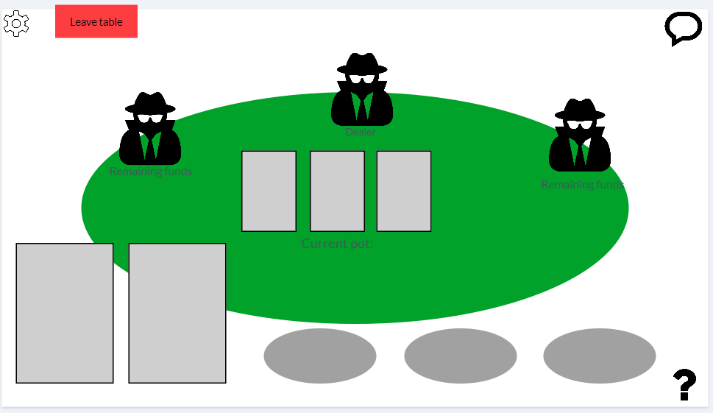

Fig 5. Table screen of initial app prototype

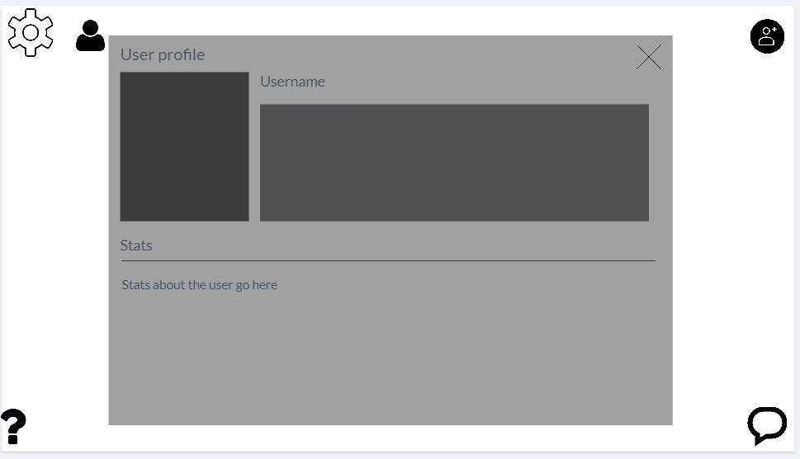

Fig. 6 User profile screen of initial app prototype

This prototype was changed after a round of testing and feedback as a result of the formative evaluation process. The 2nd prototype introduced the aforementioned ‘functional layout’ which had a higher focus on making every functional aspect (buttons) the main focus on the menu screens, and further increase their visibility in the game screen (Fig. 7).

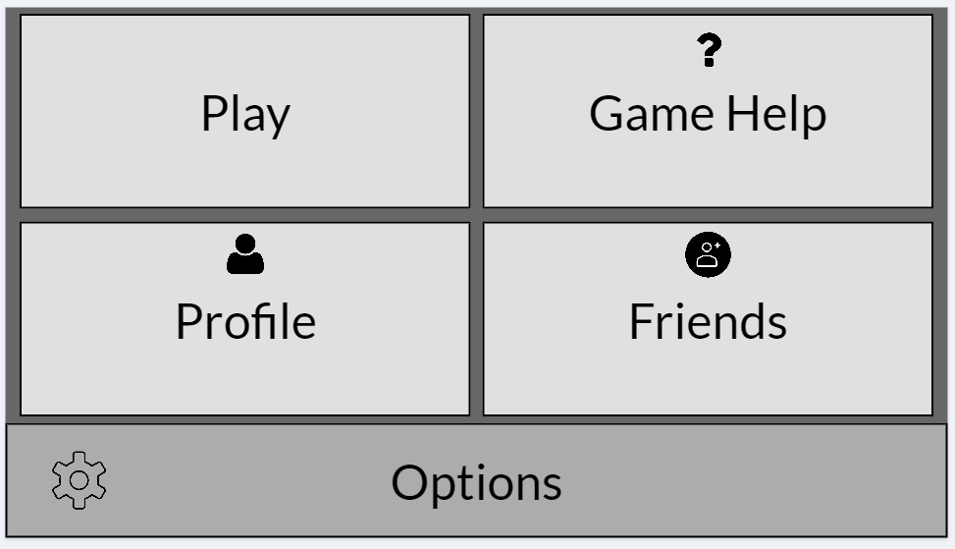

Fig. 7 ‘Functional layout’ Main Menu screen of prototype 2

This prototype was further refined to simply display text, without the associated icons as user’s felt they had no use when the function was already made clear with the text description.

An issue raised in the evaluation of this prototype was the lack of chat option in the functional layout, however we decided that the type of user that would elect to use the more visibility-centric layout is likely to either be visually-impaired or prefer to just focus on the actual game experience and as such the lack of chat visibility was not an issue.

Another major change in this prototype occurred in the normal layout of the main menu screen, with the icons that were initially in the corners representing links to different activities being moved to a navigation bar at the bottom of the screen, with a brief text description reminiscent of the design seen in Fig.3 in Section 2, which in particular was evaluated as being much clearer and easier to learn for new users who might be unfamiliar with similar technologies. Accompanying this was similar changes to the actual game screen, which also favoured larger buttons and clearer presentation whilst sacrificing aesthetic layout (Fig. 8).

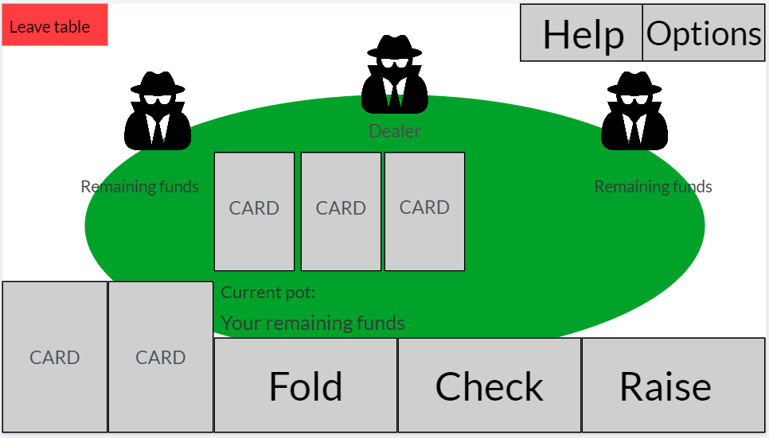

Fig. 8 ‘Functional layout’ Table screen of prototype 2

* 1. User Testing

Initial testing was conducted with a small user group of 3 people, in order to keep the feedback manageable and be able to review it quickly to implement changes to the prototype.

The test group comprised of 3 different types of user, the inexperienced, moderately experienced and experienced smartphone user. Testing proceeded in the form of a cooperative evaluation, and users were encouraged to share their thoughts as they navigated the interface, following a ‘think aloud’ protocol, from which notes were made. The advantage of this sort of testing is that the tester can see the user’s first reactions to the prototype and better understand the concerns and problems that might arise than if the user simply filled in a questionnaire.

The testing process involved a set of 3 tasks for each user, designed to allow them to interact with all the interfaces present in the prototype. The time taken to complete each task was noted and compared between users to understand how usable the system is. The user’s comments as they were performing the tasks were also noted to understand what users think during use. After the tasks were completed users were asked to give 2 ratings, the first for how obvious the steps that needed to be taken to complete each task was, and the second an overall rating on how usable the felt the system was.

Further testing will be conducted later in development of the front end in order to ensure that it is built to be as user friendly and bug free as possible. This testing will be both user testing as well as functional testing using JUnit as part of the Test Driven Development methodology.

1. **Progress**
   1. Project Management

Progress on this project has been made in 1 – 2 week intervals, with this first term focussing on mainly research and design over implementation to create a firm basis for developing the project.

In the initial plan for this project a list of tests were to be produced before beginning development however upon reflection we decided this was not feasible due to the sheer amount of tests that would need to be created and the agile development methodology meaning that requirements could very well change throughout development of the application, which we saw happen with the introduction of the ‘functional layout’ requirement 3.2. This project goal was adjusted to better fit with the principle of Test Driven Development, by creating tests as appropriate before beginning development on specific features of the project.

Further revision to the initial project plan was made to switch the schedule for when front and back end development would take place. This was made as we decided it would be naïve to leave back end development last as there would be little time to deal with potential bugs or issues that may occur. As such we revised the schedule to create only the basic, necessary components of the user interface such as the main menu and navigation first, followed by developing the back end functionality fully and then completing the front end functionality. The proposed ‘functional layout’ is the best candidate for initial implementation to allow for immediate testing of back end interaction and this is the current focus of work during the creation of this Interim Report.

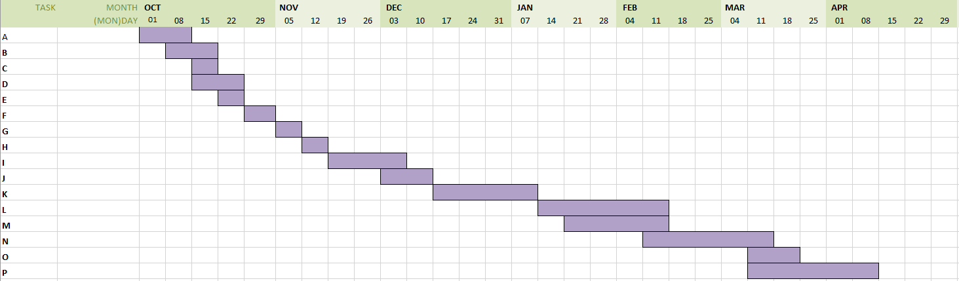

Fig. 9 Original Gantt Chart for project plan, see Appendix A for Task key

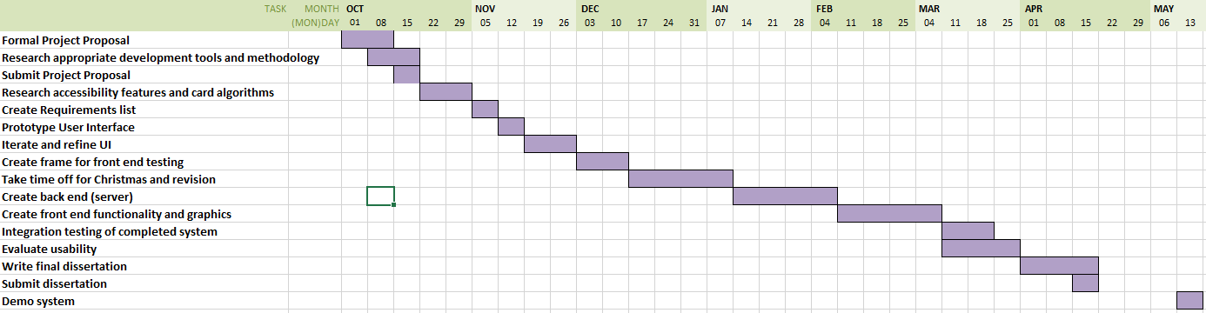

Fig. 10 Revised Gantt Chart for project plan

This revised timeline includes time after completion of the project to perform integration testing that will focus on ensuring the front end (client) interacts with the back end (server) in a correct and expected manner. Furthermore we have time in parallel with this for final user testing to gauge usability of the app which will also serve as extra testing for the app since it can be hard for a developer to write tests that can cover all possible interactions between the user and application.

* 1. Contributions and Reflections

Overall I think the project so far has been sufficiently built upon from the original brief with its own unique features, that distinguish it from other existing applications. I believe the addition of accessibility features in games is something that has not been given much attention on the Android platform. With the existing developer support for such features I believe their implementation should prove to be an achievable goal with real life applications for users who desire better gaming experiences and.

I am unsatisfied with the current pace of work over this first half. The main issue behind this being my own underestimation of how much research and planning I would need to understand the exact scope of what this project is attempting, and I will have to increase my work pace in order to successfully meet the project requirements that have been set for after the holidays. I am confident in being able to achieve this however as the research and planning I have completed over this period has provided me a solid basis to begin development on the project.

*Appendix A*

Key for Fig. 9

1. Write a completed rough formal project proposal
2. Research extensively into the most appropriate tool(s) for development and testing
3. Finish formal project proposal with feedback from supervisor
4. Research into the system features for development of accessible apps and the feasibility of implementing such systems, as well as potentials algorithms for card shuffling
5. Create a list of requirements
6. Create an initial list of tests
7. Prototype UI designs
8. Receive feedback on designs and iterate on it until a satisfactory design is reached
9. Produce interim report
10. Produce UI frame for game
11. Take time off for Christmas holidays
12. Develop functionality of poker game on client side front end
13. Integrate functionality with UI
14. Develop backend
15. Complete testing of apps usability between users of varying ability
16. Write final dissertation detailing the successes of the project and the problems encountered and overcome

# References

Anon., 2007. *World Series of Poker Retrospective: Horseshoe History.* [Online]   
Available at: https://gaming.unlv.edu/WSOP/history.html  
[Accessed 14 November 2018].

Anon., 2015. *AudioGames.net Forum.* [Online]   
Available at: http://forum.audiogames.net/topic/13872/android-accessible-games-please/page/2/  
[Accessed 10 November 2018].

Foster, R. F., 1937. *Foster's Complete Hoyle: An Encyclopedia of Games.* New York: Frederick A. Stokes.

Joy, K. & Ricaurte, J., 2011. TapBeats: Accessible and mobile casual gaming. p. 2.

Liu, Y. & Li, H., 2011. Exploring the Impact of Use Context on Mobile Hedonic Services Adoption: An Empirical Study on Mobile Gaming in China. *Computers in Human Behavior,* 27(2), p. 9.

Morris, J. T., Sweatman, W. M. & Jones, M. L., 2016. Smartphone Use and Activities by People with Disabilities: User Survey 2016. *The Journal on Technology and People with Disabilities,* p. 18.

Neal, A., 2011. *The Evolution of Poker, From Origins to Texas Holdem,* s.l.: Ezine Articles, http://ezinearticles.com/?The-­Evolution-­of-­Poker,-­From-­Origins-­to-­Texas-­Holdem&id=6544601.

Newzoo, 2018. *Global Games Market Report,* s.l.: Newzoo.

Pew Research Center, 2018. *pewinternet.org.* [Online]   
Available at: http://www.pewinternet.org/fact-sheet/mobile/  
[Accessed 15 November 2018].